Equation of Line
Y=mx+c
m=gradient, angle of the line to x-axis (slope)
c=is intercept on y-axis (which point in y the line cuts)

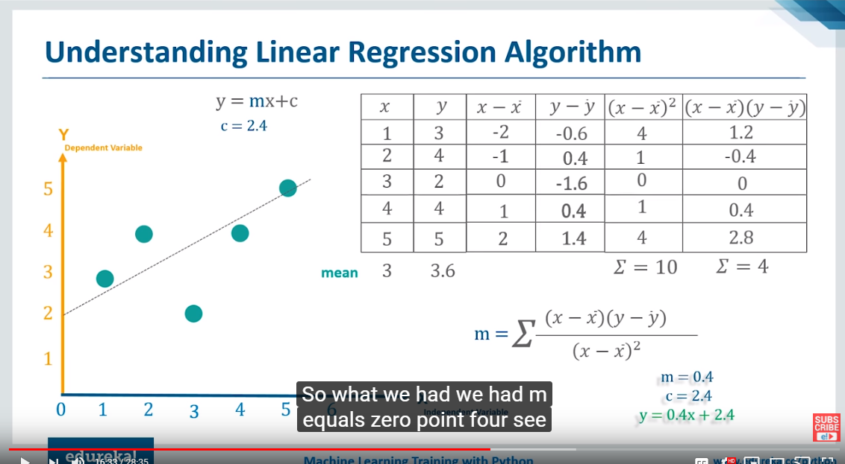

When data points given (x and y) find m first
Then find c using m value ,to find c value x and y value is mean of x and y
Now substitute the values of x in the equation and find y values. This the regression line
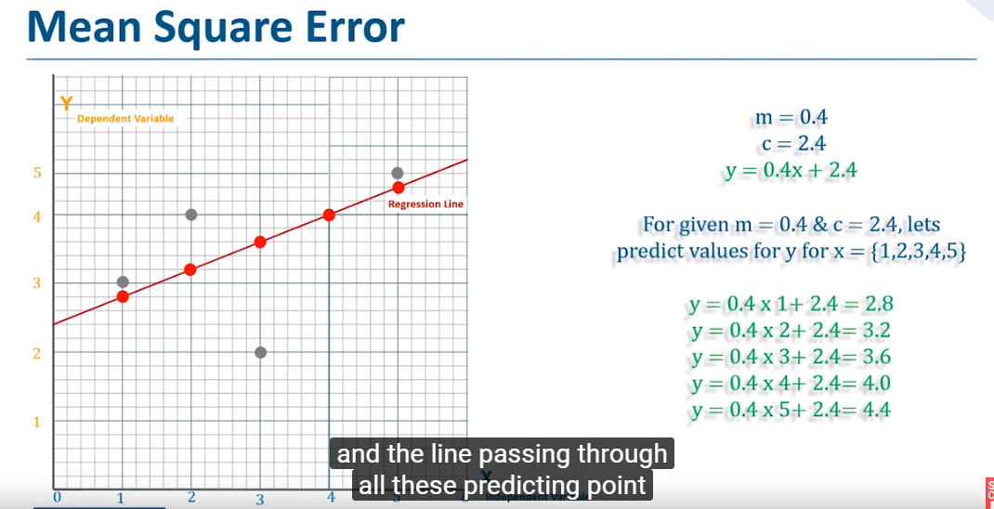

Find the R square value
